Name: Vallabhu Hemanth
Roll Number: AM.EN.U4ELC21037
Program: B.Tech
Branch: ELC
Semester: s1
------------------------------------------------------------------------------------------------
Task1
Circuit name -simple led blink program
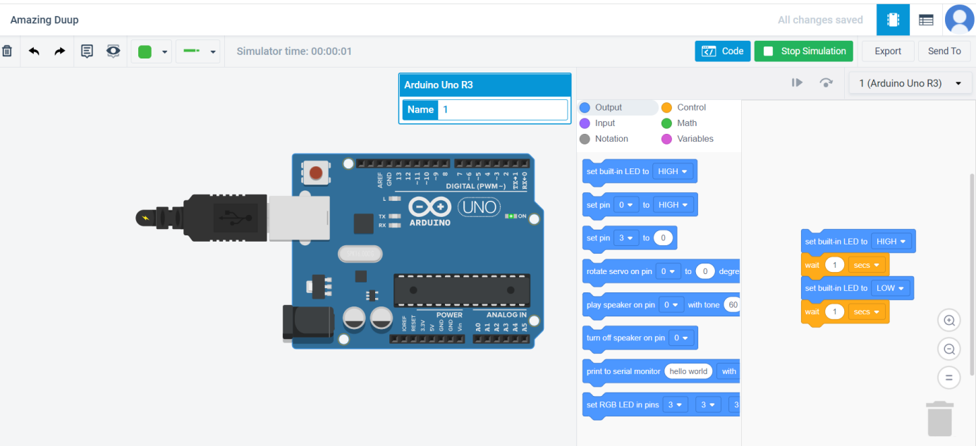
Components used in the circuit - arduino uno
Values of components used in the circuit-
The voltage of the arduino uno is 5 volts
Observation
The connections of the circuit are correct .The code used in the circuit is correct.when the circuit is getting stimulated the bulb the arduino uno gets lighted up.

Task2
Circuit Name: LED Blink Using Breadboard and External LED
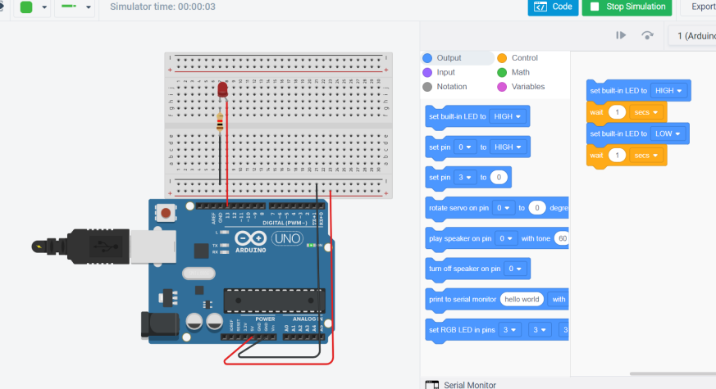

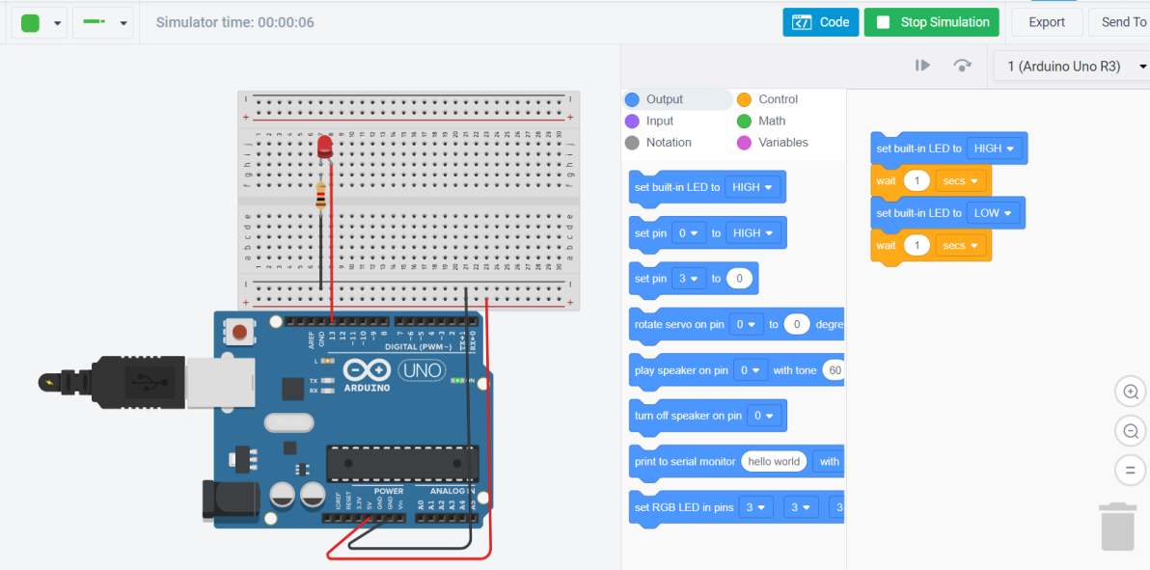
Components used in the circuit: Arduino uno, Resistor, LED, Connecting wires and a Breadboard.
Values of the components used in the circuit:
The operating voltage of the Arduino uno is 5Volts.
The external voltage of 13 Volts is being used.
The resistor has a resistance of 1K ohm.
Observation: The connections of the circuit are correct. The code used in the circuit is correct. When the circuit is getting stimulated, the bulb in the breadboard gets lighted up as the current starts to flow.

Task3
Circuit Name: Traffic Light Display with Three LEDs (Yellow, Green, Red)
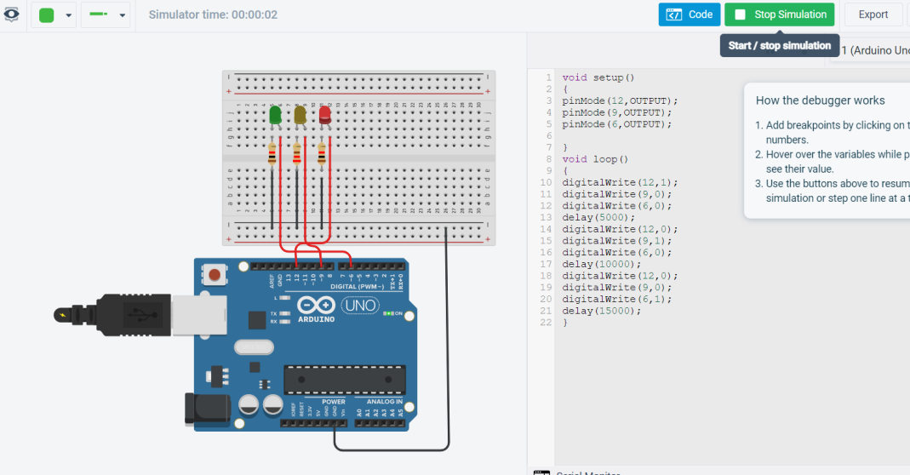

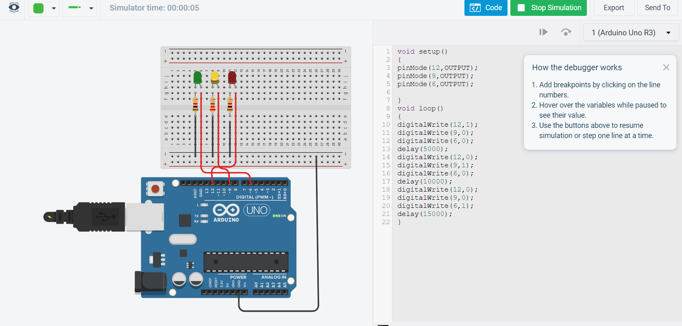
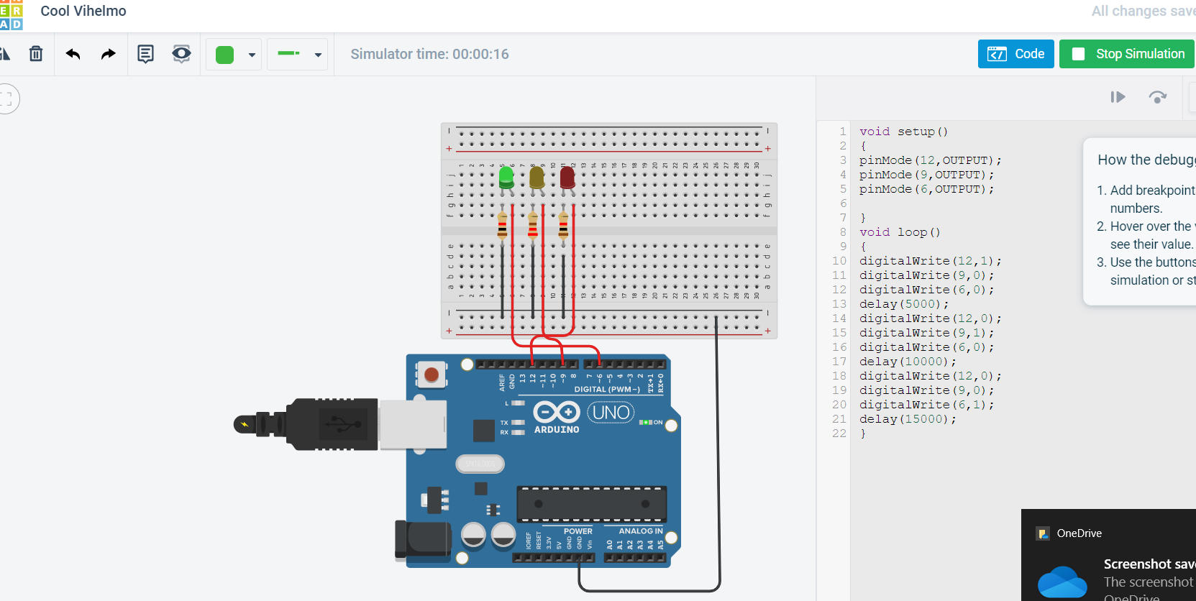
Components used in the circuit: Arduino uno, 3 Resistors, 3LEDs(Red, Yellow, Green), Connecting wires and a Breadboard.
Values of the components used in the circuit:
The operating voltage of the Arduino uno is 5Volts.
The external voltage of 13 Volts is being used.
The resistor has a resistance of 1Kilo ohm.
Observation: The connections of the circuit are correct. The code used in the circuit is correct. When the circuit is getting stimulated, the bulbs in the breadboard get lighted up as the current starts to flow. The 3 leds light up with a time delay of 5, 10, 15 secs, respectively, representing the traffic lights.

Task4
Circuit Name: LED (ON/OFF) Using a Photoresistor

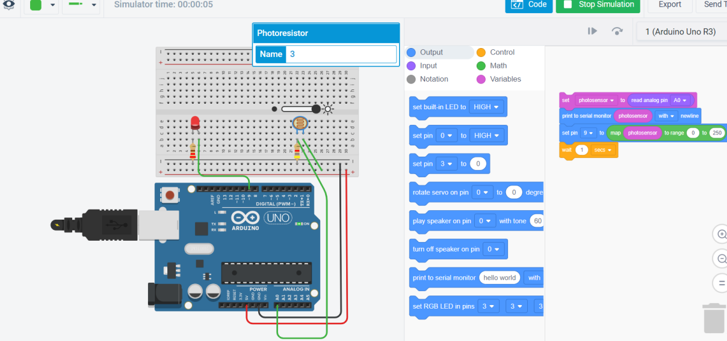
Components used in the circuit: Arduino uno, 2 Resistors, LED, Connecting wires, Photoresistor and a Breadboard.
Values of the components used in the circuit:
The operating voltage of the Arduino uno is 5Volts.
The external voltage of 13 Volts is being used.
The resistor has a resistance of 1Kilo ohm and connected with the photoresistor and another one to the led with 220ohm.
Observation: The connections of the circuit are correct. The code used in the circuit is correct. When the circuit is getting stimulated, the bulbs in the breadboard get lighted up as the current starts to flow. The photoresistor connected in the circuit changes its resistances.

Task5
Task 5.1
Circuit Name: Push Button Digital Input with Arduino

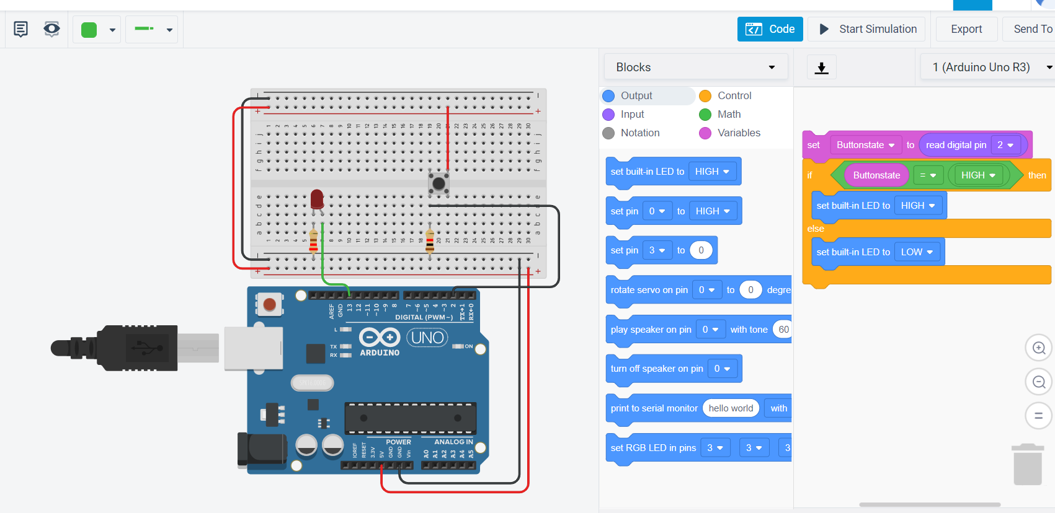
Components used in the circuit: Arduino uno, 2 Resistors, LED, Connecting wires, Pushbutton and a Breadboard.
Values of the components used in the circuit:
The operating voltage of the Arduino uno is 5Volts.
The external voltage of 13 Volts is being used for the led and for the 2 Volts.
The resistor has a resistance of 4.7Kohm and connected with the pushbutton and another one to the led with 220ohm.
Observation: The connections of the circuit are correct. The code used in the circuit is correct. When the circuit is getting stimulated, the bulbs in the breadboard get lighted up as the current starts to flow. The pushbutton when pressed let’s the current flow through it and lets the led glow. This stimulation works on the principle that current flows through the least resistive path.

Task 5.2
Circuit Name: Arduino Alarm Using Piezo Buzzer

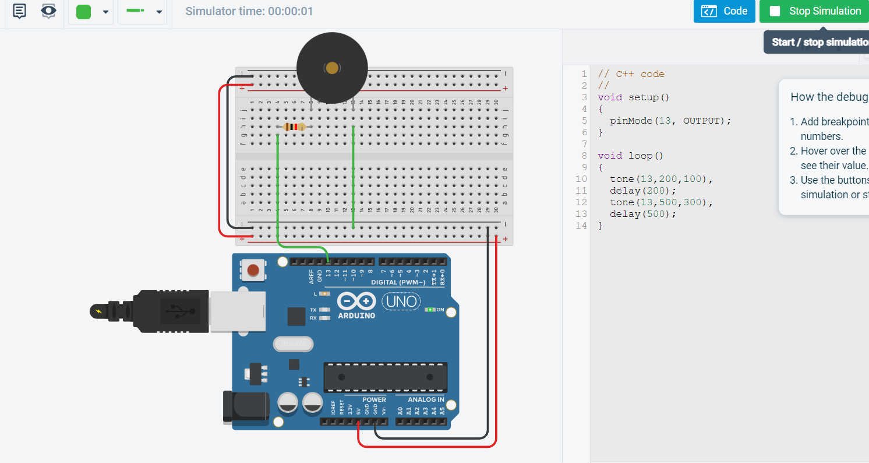
Components used in the circuit: Arduino uno, Resistor, Connecting wires, Piezo buzzer and a Breadboard.
Values of the components used in the circuit:
The operating voltage of the Arduino uno is 5Volts.
The external voltage of 13 Volts is being used for the Piezo buzzer.
The resistor has a resistance of 1kilo Ohm and connected with the piezo buzzer.
Observation
The connections of the circuit are correct. The code used in the circuit is correct. When the circuit is getting stimulated, the piezo buzzer in the breadboard gets played up as the current starts to flow. The tone of the piezo buzzer is set and changed in order to create various sounds.

Task 5.3
Circuit Name: LED Chaser with Arduino

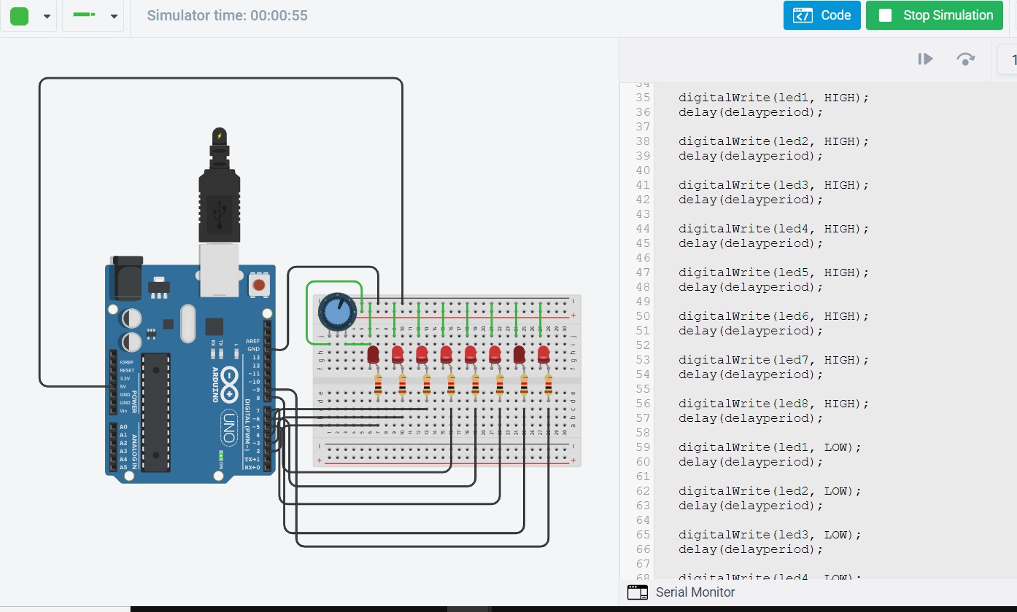
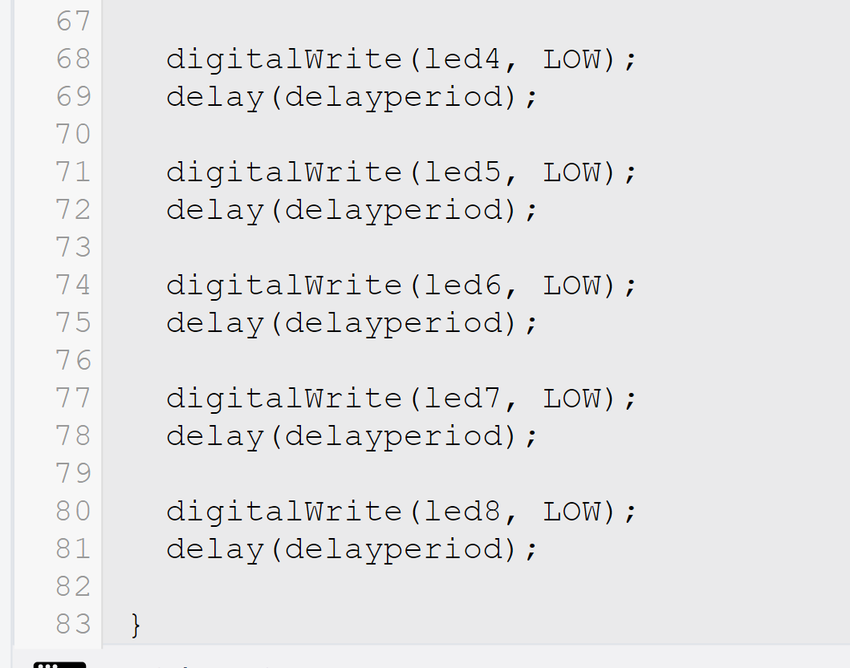
Components used in the circuit
Arduino uno, 8 Resistors, Connecting wires, 8 LEDs, Potentiometer and a Breadboard.
Values of the components used in the circuit:
The operating voltage of the Arduino uno is 5Volts.
The external voltage for leds is applied from 2 to 9 Volts respectively.
The potentiometer is connected to 13 Volts respectively.
The resistor has a resistance of 1Kohm is connected with each led respectively.
Observation
The connections of the circuit are correct. The code used in the circuit is correct. When the circuit is getting stimulated, the leds glow up flowing a pattern as the current starts to flow. The potentiometer here helps us to control the amount of the voltage that needs to be flowed in the circuit.

Task 5.4
Circuit Name-Arduino Piano with Piezo Buzzer

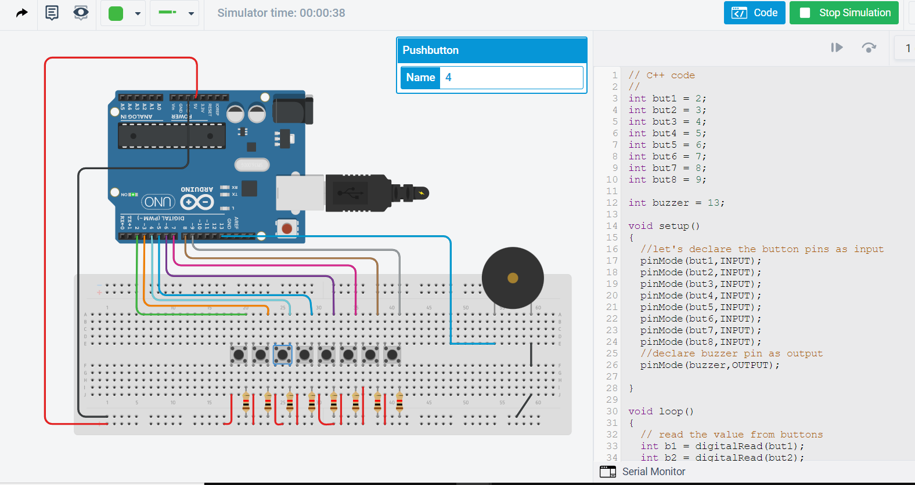
code

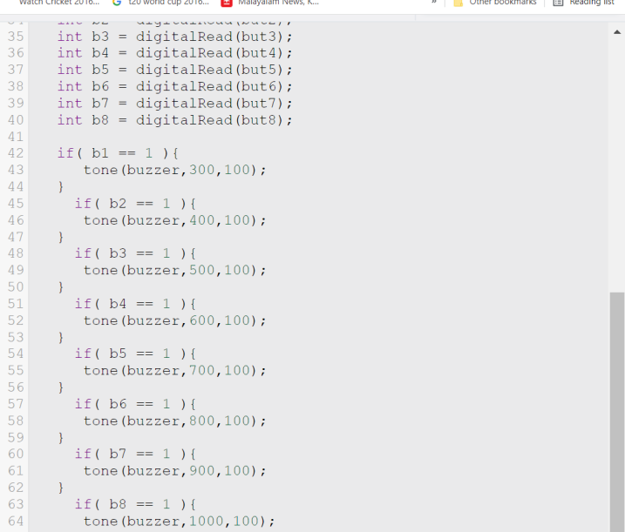
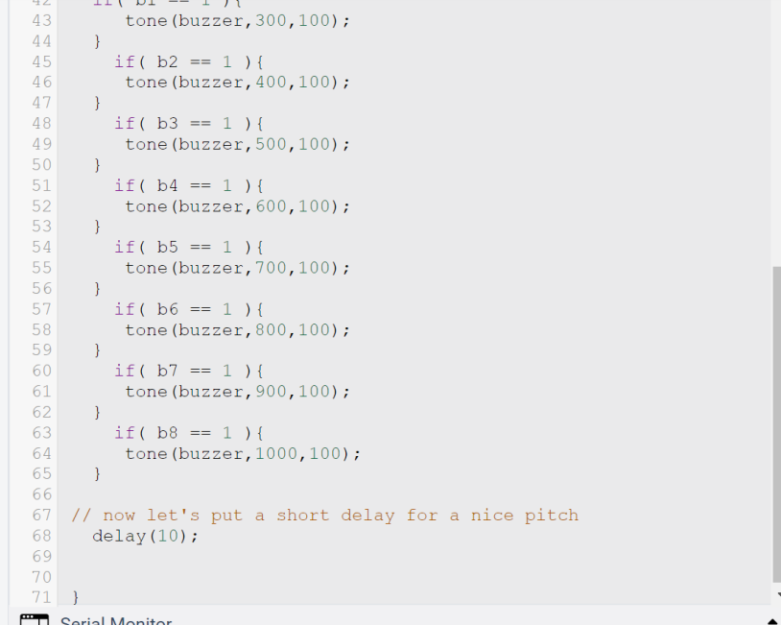
Components used in the circuit:
Arduino uno, 8 Resistors, Connecting wires, 8 Pushbuttons, Piezo buzzer and a Breadboard.
Values of the components used in the circuit:
The operating voltage of the Arduino uno is 5Volts.
The external voltage for leds is applied from 2 to 9 Volts respectively.
The piezo buzzer is connected to 13 Volts respectively.
The resistor has a resistance of 1Kilo ohm is connected with each led respectively.
Observation
The connections of the circuit are correct. The code used in the circuit is correct. When the circuit is getting stimulated, the piezo buzzer starts to play as the current starts to flow. The musical pattern by piezo buzzer creates a piano effect.

